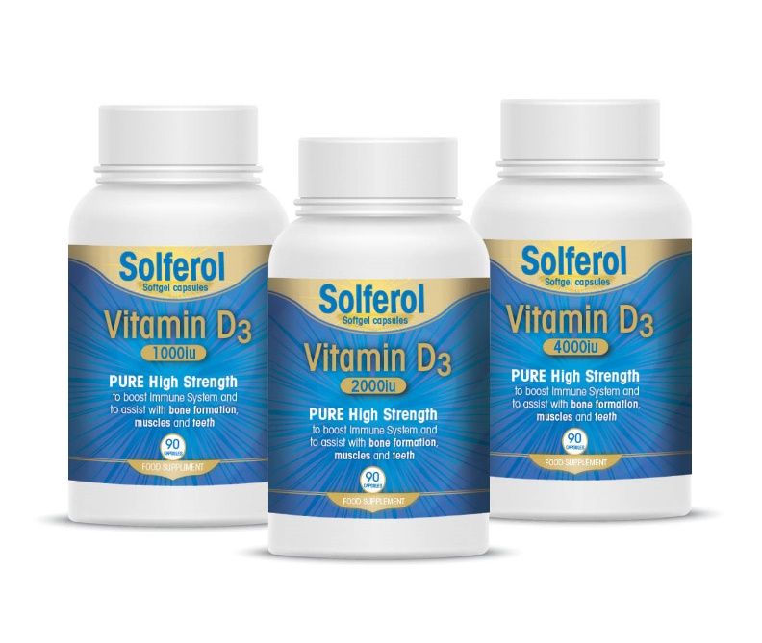
Solferol Vitamin D
September 2021
WINDZOR Pharmaceuticals are pleased to announce the launch of Solferol Vitamin D
Solferol Vitamin D 90 Soft Gel Capsules 1000IU RRP€11.99
Solferol Viramin D 90 Soft Gel Capsules 2000IU RRP€13.99
Solferol Vitamin D 90 soft Gel Capsules 4000IU RRP€15.99
Solferol Vitamin D is a high quality Vitamin D3, to boost immune system and to assist with bone formation, muscles and teeth.
Solferol is available from UD and Unipahr from 1st September 2021.
For more information contact us at info@windzorpharma.com or visit www.windzorpharma.com

